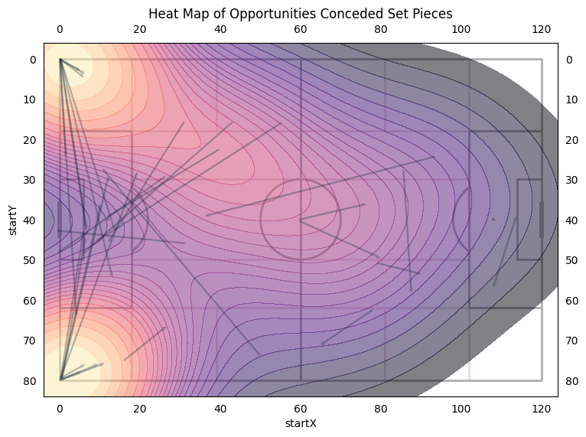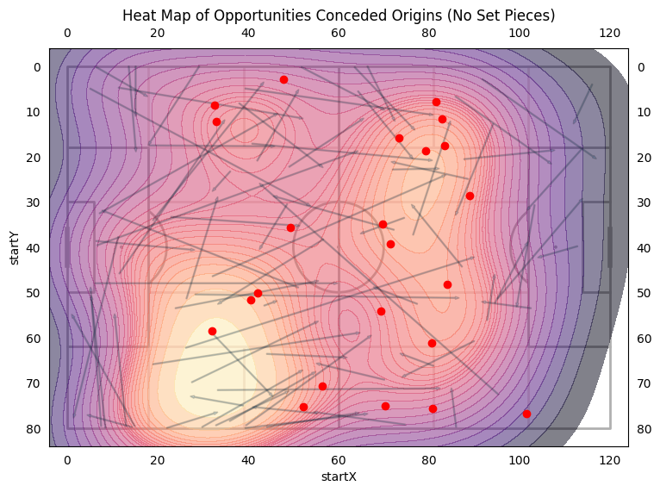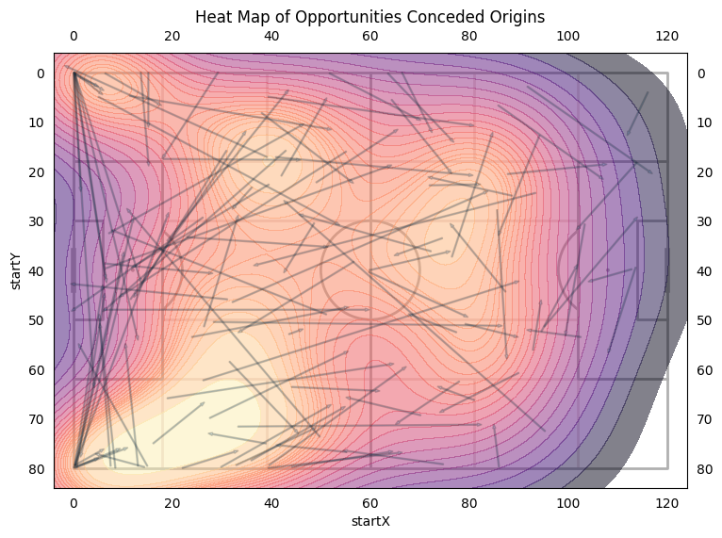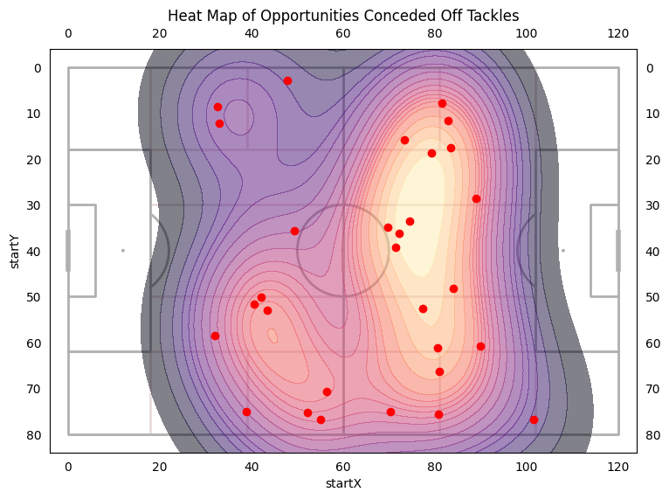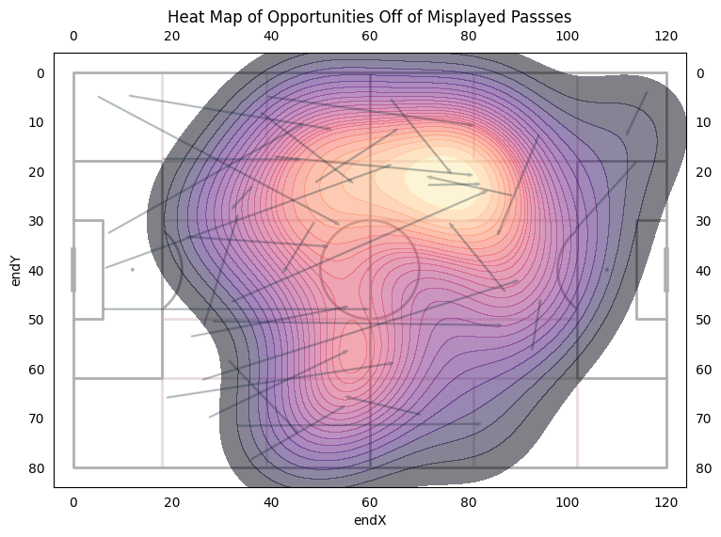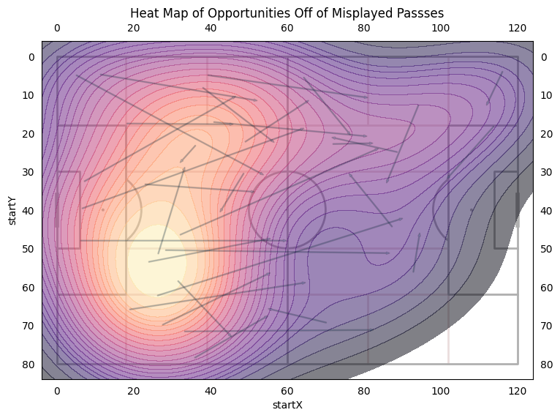

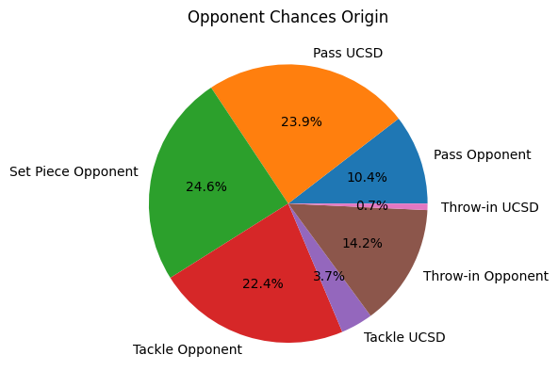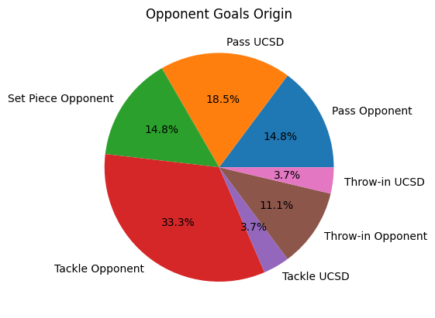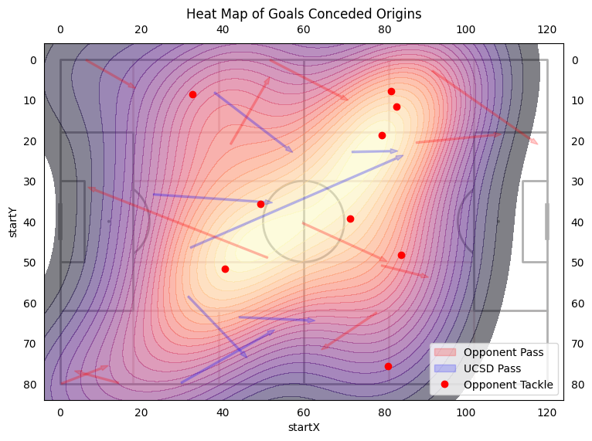

Origins Conclusion:

* Majority of Chances off of Set Pieces, Misplayed Passes, and Tackles
* Majority of Goals off of Tackles
* More opportunities for opponents tend to start on the right side.
* Opponent tackles that lead to opportunities in the middle field and transition to attacking third.
* Misplaced passes that lead to chances tend to start in our defensive third particularly on the right side and the least successful area to pass into was the left flank.

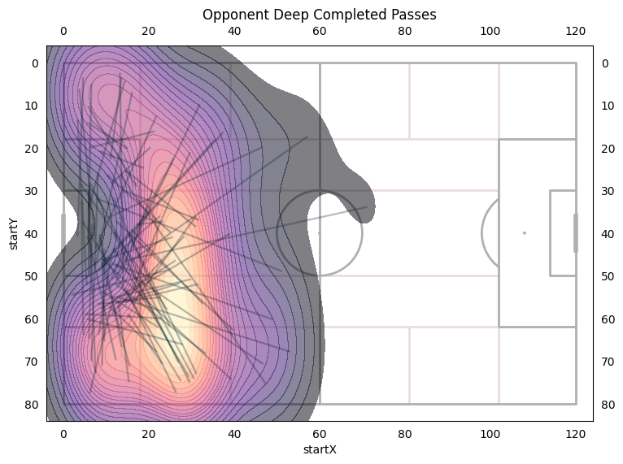

* Opponents average 8.8 deep completed passes per game
* Deep Completed Passes tend to start from 10 yards off the top of the box with a slight favor to our defensive right side.
* 65.4% of opponents shots were within our box.
* 88.8% of opponents' goals were within our box.
* 81% of shots assisted by a pass
* 19% of shots assisted by a tackle/block
* 59.2% of assists are also deep completed passes
* 30% of assists are tackles/blocks

